GIKI PROCTOR

SRS + SDS

Group Members
Hamid Ali 2019144
Ameer Hamza 2019293
Mian Ali Shah 2019235

Advisor: Sir Ali Shaukat

Revision History:

Revision History | Date | Comments
1.00 | 28/09/22 | 1st FYP Draft
2.00 | 05/12/22 | First FYP Iteration

Document Approval:
The following document has been accepted and approved by the following:

Signature | Date | Name

List of Contents
1 INTRODUCTION 5
1.1. PURPOSE 5
1.2. PRODUCT SCOPE 5
2 OVERVIEW 6
2.1 THE OVERALL DESCRIPTION 7
2.2 PRODUCT PERSPECTIVE 8
2.3. PRODUCT FUNCTIONS 8
2.4. USER CHARACTERISTICS 8
2.5. CONSTRAINTS 9
2.6. ASSUMPTIONS AND DEPENDENCIES 9
3 STATE OF THE ART 9
3.1. LITERATURE REVIEW 9
3.2. EXISTING SYSTEMS 10
4 MODEL 11
4.1. MODEL VIEW CONTROLLER 11
5 USER/SYSTEM REQUIREMENTS 13
5.1 External Interface Requirements 13
5.1.1 User Interfaces 13
5.1.2 Hardware Interfaces 19
5.1.3 Software Interfaces 19
5.1.4 Communication Interfaces 19

6 Functional Requirements 20
6.1 Functional Requirements with Traceability information 20
7 Nonfunctional Requirements & Software System Attributes 29
7.1 Performance Requirements 29
7.2 Saftey Requirements 29
7.3 Security Requirements 29
7.4 Software Quality Attributes 29
7.5 Business Rules 29

8 Project Design/Architecture 30

List of Figures

Figure 15: Sign in page 14
Figure 18: Join Exam 15
Figure 19: Face ID 17
Figure 20: Suspected Individual View 17
Figure 2: Use case Diagram 31
Figure 3: Class Diagram 32
Figure 4: Student Sequence Diagram 33
Figure 5: Examiner Sequence Diagram 34
Figure 6: Component Diagram 35
Figure 7: Student Activity Diagram 35
Figure 8: Examiner Activity Diagram 36
Figure 9: State Chart Diagram 36
Figure 10: Deployment Diagram 37

INTRODUCTION

PURPOSE
The purpose of Giki proctor is to take online exams with AI Proctoring. The concept of online exams has become more widespread to oblige everyone to education and to spread equal and high-quality opportunities that the learner deserves, anywhere and anytime. The result in online exams are calculated quickly and students don’t have to wait for weeks/months for result.
We are building web application where institute can take online exams and they can easily detect if there is any malicious activity such as using mobile phone, browsing on internet etc.
When an exam is conducted remotely, hundreds of thousands of students can appear for the exam, without the need to spend on travel and accommodation. This also solves the problem of scheduling exams across various exam centers, hiring invigilators, providing security to these centers, etc.

PRODUCT SCOPE
There is no doubt that online exams usher in advantages of cost-cutting as it saves time, money and efforts involved in travel and provision of center facilities. Stationery is saved too. These are quick and simple as compared to the traditional exam method using pen and paper. We have tried to reduce the bandwidth by putting the option of level, if student breach certain restriction, then an alert will be shown, there will be certain threshold after that student will be removed/put on hold and in this way bandwidth will be reduced. In this app examiner will be able to create different exams for different students, random questions will be allotted to different students from the question bank. Online examination system ensures safe and secure data storage. Our products like GIKI Proctor, Online Examination System help to secure the data related to students, examinations, question items and results.

Table 1: Terms used in this document and their description

NAME | DESCRIPTION
HTML | Hypertext Mark-up Language, a standardized system for tagging text files to achieve font, color, graphic, and hyperlink effects on World Wide Web pages.
HTTP | Hypertext Transfer Protocol ,The communications protocol used to connect to Web servers on the Internet or on a local network (intranet).
HTTPS | Hypertext Transfer Protocol Secure, It is the protocol where encrypted HTTP data is transferred over a secure connection.
API | An API is a set of programming code that enables data transmission between one software product and another. It also contains the terms of this data exchange.
CRUD | Create, Read, Update and Delete

OVERVIEW

The main goal of this project is to build an online examination web app with AI Proctoring. We will be using different models to build this project such as deep learning, image processing etc. This project will reduce the hectic job of evaluating the papers manually. It will allow faculty to generate the random questions and insert answer key as well. In short it will provide convenience for both students and teacher.

2.1 THE OVERALL DESCRIPTION

Computerized and online systems have been increasing rapidly In this current era and we know how this technology plays important rule in education. Computers and internet have brought a dramatic change in the current education system. Online examination system will reduce the burden of both students and teachers. This web application will be user friendly to avoid any sort of inconvenience. It will be developed using MERN STACK. MERN stands for MongoDB, Express, React, Node, after the four key technologies that make up the stack.
it’s an open-source code that’s constantly being improved upon by tech experts from around the world. All the components of the MERN stack are open source, and thus you can use it to create robust web apps. It is much faster than PHP. It uses NOSQL database names MongoDB. MongoDB will be used for the verification of login when every time student’s login on the web Application, it will check for verification of that account through MongoDB. It is quite faster. The question bank will be also stored in this MongoDB. The server can be accessed from any location.

It is very secure. Video streaming will be done through WEBRTC. WebRTC (Web Real-Time Communications) is an open source project that enables real-time voice, text and video communications capabilities between web browsers and devices. WebRTC provides software developers with application programming interfaces (APIs) written in JavaScript. With WebRTC, data transfer occurs in real time without the need for custom interfaces, extra plugins or special software for browser integration.

WebRTC enables real-time audio and video communication simply by opening a webpage. The working of this app will be very simple, like every time students will login on the web app and then they have to prove their facial identity in to order to attempt the paper and this will be done using CNN. AI Proctoring will be implemented using Long Short-term Memory (AI Model).

Various proctoring models will be implemented such as Facial movements, more than one person the screen and eye movement etc. Then invigilator will schedule and exams, the students will join it and random questions will be shown to every student. During the examinations if found using any illegal means, it will be informed to invigilators instantly and final call will be of invigilators that whether a student should continue the paper or not.

2.2 PRODUCT PERSPECTIVE
The purpose of building online examination app is a very secure platform where students can give exams. There are main functionalities of these web app. The first one is to take online exams. The second one is AI proctoring and the third one is evaluating the exams.

2.3 PRODUCT FUNCTIONS
- The Invigilator should be able to upload and schedule exams.
- The Invigilator should be able to view live streams of specific students.
- The Invigilator should be able to filter students' live stream on the basis of suspicion level.
- The Invigilator should be able to download attempted exams.
- Students should be able to take online exams.
- Students should be able to resume the exam from the next question on disconnection.
The Artificial Intelligence model should classify students in real-time

2.4 USER CHARACTERISTICS
There are two categories of users of the system. One is the Invigilator and the other is the student.
- The Invigilator has the human limit on viewing concurrent streams, so the system allows filtering out of clean students.
- The students may face disconnectivity upon which the system saves the current progress, so the student can resume the exam

2.5 CONSTRAINTS

The hardware on which the Model is deployed can cause issues in predicting in real-time.

Low-Quality stream can make it difficult to detect suspicious behavior.

Lighting Conditions can affect the prediction.

If everyone is cheating, then classifying them would be difficult.

2.6 ASSUMPTIONS AND DEPENDENCIES
These assumptions may change during the implementation and new features may be added. SRS documents will be updated according to these changes.

WebRTC:
  - Video Conferencing will be created using WebRTC.

2. Facial Recognition:
1. This will be implemented on the scenario if the database has multiple pictures of each student on which the model is trained.

3. Neural Network:
  - LSTM-RNN will be used to classify students

3 STATES OF THE ART

- LITERATURE REVIEW

- In paper [1] the authors studied the testing pattern grades in four e-campus courses at Troy University with 76 graduate students. The research found major differences in average test grade scores between tests taken remote online without a proctor and with proctor.
- In paper [2] To demonstrate and maintain academic integrity, some institutions require proctor supervision of online exams.
- In paper [3] Online education continues to grow, bringing opportunities and challenges for students and instructors. One challenge is the perception that academic integrity associated with online tests is compromised due to undetected cheating that yields artificially higher grades.

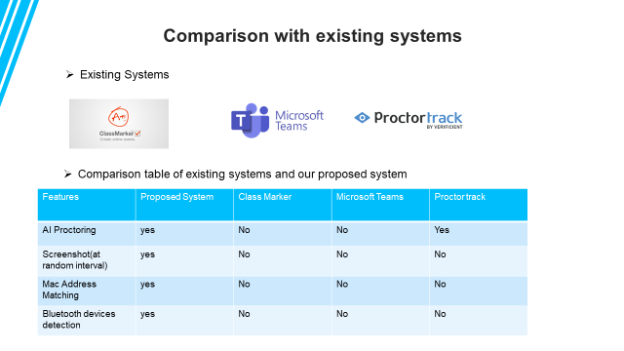
- EXISTING SYSTEMS

Design

MODEL VIEW CONTROLLER
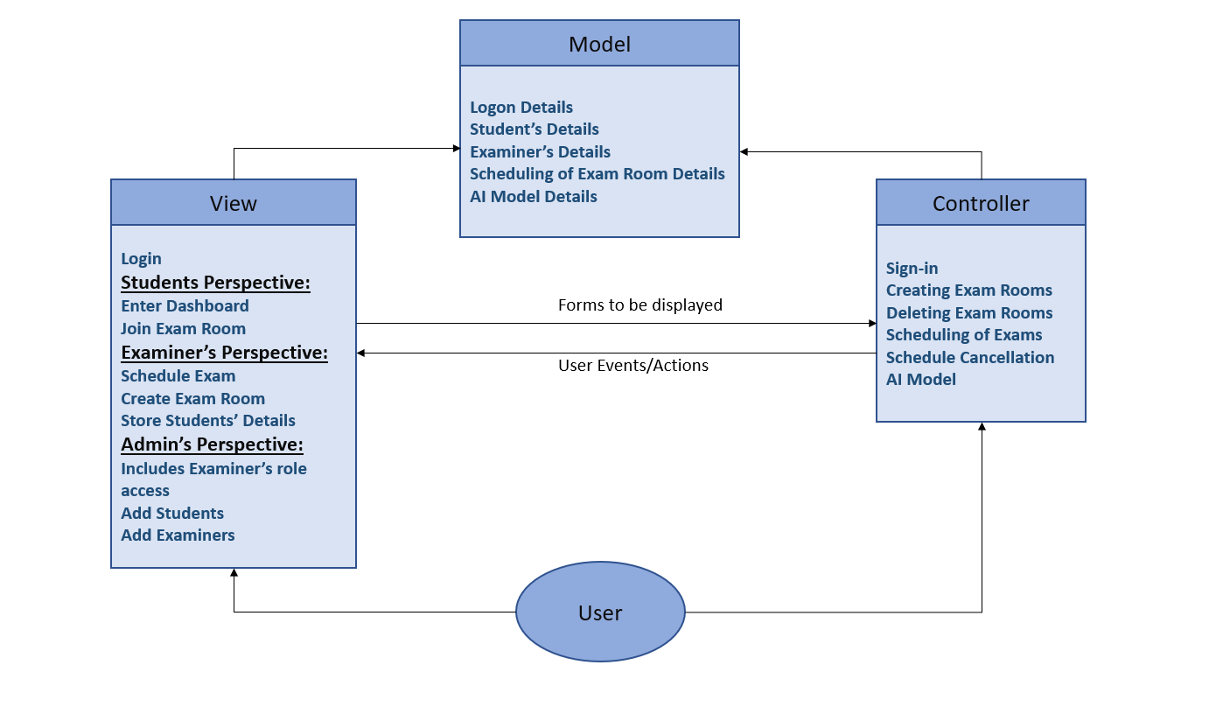

WHY DO WE USE MVC?
Architectural design in our system is the MVC - Model View Controller.
It is a software design pattern mostly used for developing UI (user interfaces) that divide the related program logic into three interconnected elements. The system performs its job by separating external representations of information from the internal information is presented to and accepted by the user. For designing the page layout this kind of pattern is used.

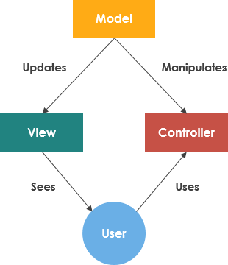

Components

Model
Our model uses Mongo DB. Students and Admin/invigilators both are connected to Mongo DB. It directly manages the data, logic, and rules of the application.

View
Our main view is divided into two main section, Admin/Invigilator and Students. Both have their specific login which takes them to their respective interfaces in web application.

4.2.3 Controller
This part controls our Model. Following are the control elements which affects our model:
- As a user signs in, an authentication process is started using Node JS’ framework Express.
- Invigilators can schedule an exam which will be updated in the database.
- When Order is delivered, order status is changed to Delivered in the Database

MODULE IDENTIFICATION

Web Application
Our web app will include three user Interfaces for: students, administrators, and invigilators. Invigilators will be able to CRUD students and schedules for exams and arrange meetings. Students can join the meeting using their respective secured login (username and password) provided by their institute.

Web RTC
It allows students and invigilators to have real-time communication via simple APIs. Invigilators will have the full control of the meeting room (start exam, end exam, cancel student exam, etc.). Invigilator can see filtered streams or all streams depending on his bandwidth. So, there would be one-way video conferencing (Invigilator can see students but students cannot see each other or the invigilator).

AI Model
Face spooking, eye detection, mouth opening detection, audio feed, mobile detection, will be used to create a pattern which will be sent to pattern recognition model for classification of students in 3-5 degree of suspiciousness.

EXTERNAL INTERFACE REQUIREMENTS

5.1.1 User Interfaces
All interactions with our AI proctoring system will occur through a web-based interface. Our system will be accessed through a secure user interface requesting the user a fixed username and password. Any unexpected system operation will give user a web page error, stating the cause of the error. Screens shown below will be used for this purpose:
- Login Screen:
- Username
- Password
- Entering Questions:
- Questions
- Question Options
- Correct Answer

- Exam Details Screen:
- Type and Name of Exam
- Number of Questions
- Time Limit

- Student List screen:
- Student Name
- Student Regnum

- Student exam Screen:
      - Display of Question with respective options
      - Button to go to next Question only
- Meeting screens:
      - As a student
      - As an examiner/invigilator
- Result Display Screen:
- Total Marks
- No of correct questions
- No. of Incorrect Questions
- No. of Unattempt Questions
- Result
These Interfaces shown below are subject to change during their development phase.

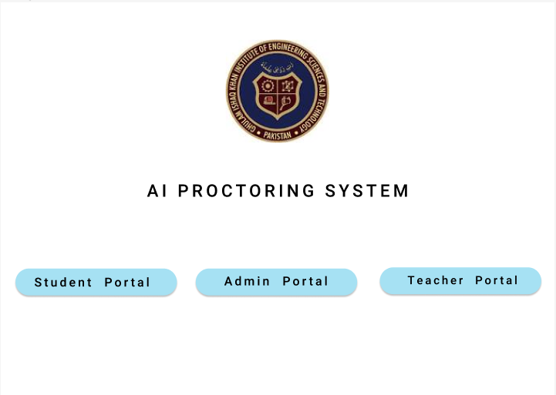

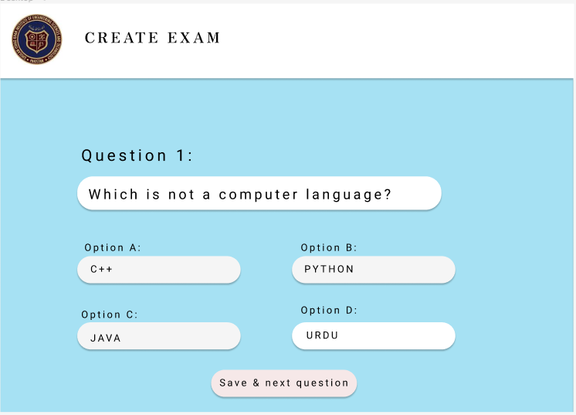
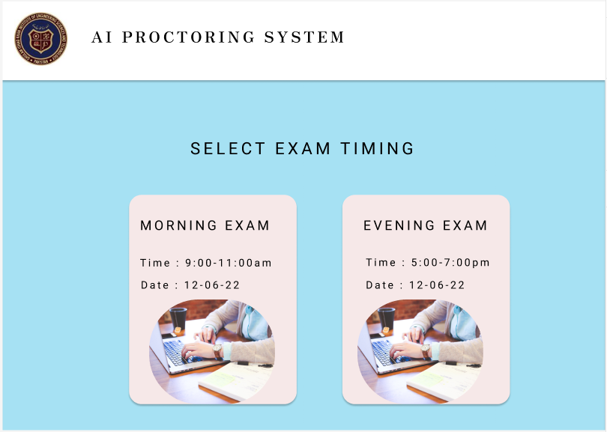
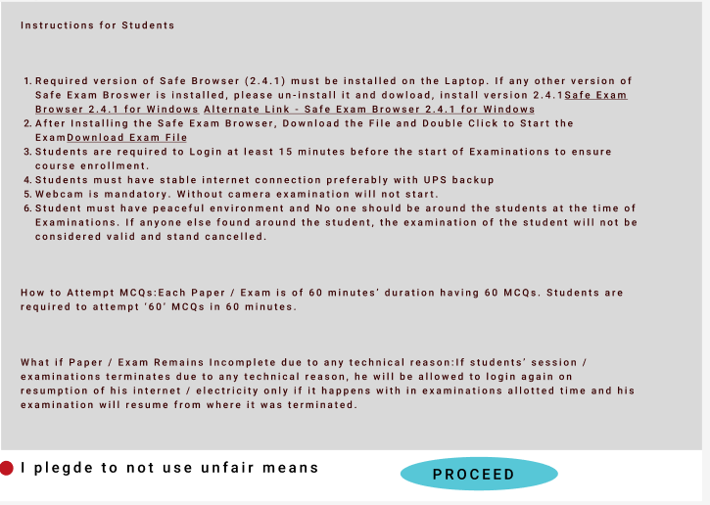
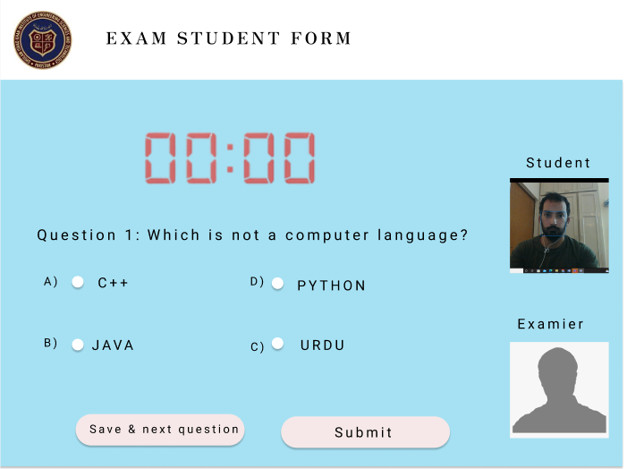
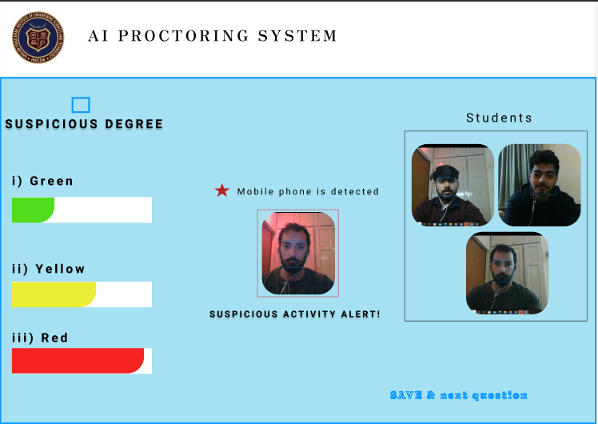
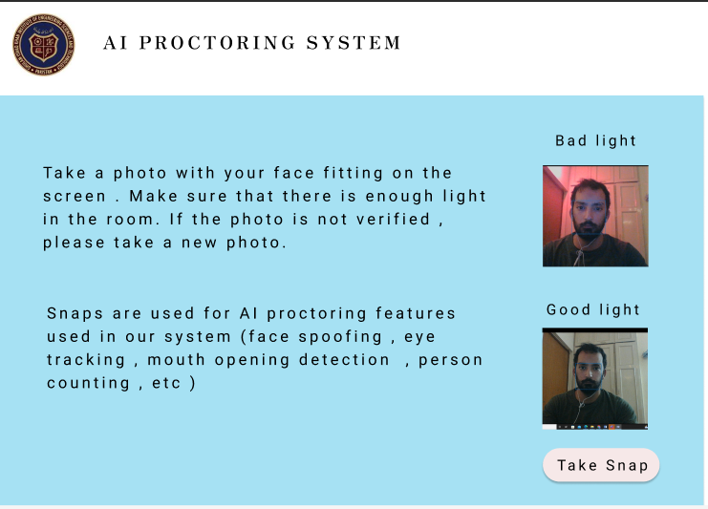



5.1.2 Hardware Interfaces

- All client-side components must execute on workstation-class and personal-class computers and all server-side components must execute on server-class computers
- Microphone for VOIP
- Web & database server.
- Camera for web conferencing

Any further system interactions will be handled by the OS and any other supporting software systems.

5.1.3 Software Interfaces

- The software interface should follow the MVC (Model-View-Controller) model for modeling and rendering data objects.
- The interface must be able to connect to a database to store XML schema defined using XSD and data streams.
- Source and destination formats for data must include XML and may also include Extensible Style-sheet Language Transformation (XSLT), JavaScript Object Notation (JSON), Comma Separated Value (CSV), and American Standard Code for Information Interchange (ASCII).

5.1.4 Communication Interfaces

- The communication architecture must follow the client/ server model.
- Communication between the client and server should utilize a REST-compliant web service and must be served over HTTP Secure (HTTPS).
- Our AI proctoring system will use the HTTPS protocol for communication over the internet and socketo.io in web conferencing which allows real time bidirectional event based communication.
- Exam details shall be transferred through the TCP/IP protocol suite through Mongo DB.

6. Functional Requirements

6.1 Functional Requirements with Traceability information

6.1.1 WEB APP

The software system must provide the administrator with the ability to CRUD manage user accounts (Invigilators and Students).

The software system must provide the administrator with the ability to CRUD manage groups.

The software system must provide the administrator with the ability to CRUD manage user group Exams and meetings.

The software system must provide the administrator with the ability to CRUD manage permissions assigned to users and groups.

Invigilators should be able to add students to their respective exam rooms.

Invigilators must be able to add collaborators in their rooms.

Invigilators must be able to CRUD Question Paper.

Both students and invigilators must be able to login using their respective credentials.

Invigilators should be able to Schedule, Start and End an exam.

6.1.1.10 Students must be able to join the Morning or Evening exam.
6.1.1.11 After joining the exam, the system must check if student leaves full screen mode.
6.1.1.12 Editing test paper privileges shall be removed when a student disconnects.
6.1.1.13 On reconnection previously filled exam cannot be changed.

WebRTC

6.1.2.1 WebRTC should only allow one-way communication from student to invigilator.

Invigilator must be able to see most suspicious students classified by AI model

Invigilators may be able to warn any student individually through Audio.

Invigilators may be able to hear specific students.

AI Model

Model must ensure the identity of students using facial recognition.

Model must detect any other person in the room.

6.1.3.3 Model must track the eyes of the student to prevent them from looking away from the screen.

Model may detect the student using helping material (mobile, headphones,).

Audio Feed must be used to detect talking.

Pattern Recognition Model must create a pattern of suspiciousness using above mentioned Models

Requirement ID | 6.1.1.2 |  |  |  | Requirement Type |  |  |  |  | Use Case #
Status | New | Yes | Agreed-to |  |  |  | Yes | Baselined | - | Rejected | -
Parent Requirement # | 6.1.1
Description | Invigilators can CRUD groups of students in the application.
Rationale | To allow invigilators control over their respective exam rooms.
Source |  |  |  |  |  |  |  | Source Document |  | -
Acceptance/Fit Criteria | When Invigilator interface is completed.
Dependencies | Student data from database.
Priority | Essential |  |  | Yes |  | Conditional |  | - | Optional | -
Change History | No
Requirement ID | 6.1.1.1 |  |  |  | Requirement Type |  |  |  |  | Use Case #
Status | New | Yes | Agreed-to |  |  |  | Yes | Baselined | - | Rejected | -
Parent Requirement # | 6.1.1
Description | Admin can create, read, update, and delete users in the application.
Rationale | This excludes the need for invigilators and students to create their own account.
Source |  |  |  |  |  |  |  | Source Document |  | -
Acceptance/Fit Criteria | When admin panel is completed.
Dependencies | The data required from institutes database
Priority | Essential |  |  | Yes |  | Conditional |  | - | Optional | -
Change History | No

Requirement ID | 6.1.1.6 |  |  |  | Requirement Type |  |  |  |  | Use Case #
Status | New | Yes | Agreed-to |  |  |  | Yes | Baselined | - | Rejected | -
Parent Requirement # | 6.1.1
Description | Invigilators must be able to add collaborators in their rooms
Rationale | To allow invigilators control over their respective exam rooms.
Source |  |  |  |  |  |  |  | Source Document |  | -
Acceptance/Fit Criteria | When Invigilator interface is completed.
Dependencies | Student data from database.
Priority | Essential |  |  | Yes |  | Conditional |  | - | Optional | -
Change History | No
Requirement ID | 6.1.1.7 |  |  |  | Requirement Type |  |  |  |  | Use Case #
Status | New | Yes | Agreed-to |  |  |  | Yes | Baselined | - | Rejected | -
Parent Requirement # | 6.1.1
Description | Invigilators must be able to CRUD exam paper
Rationale | For conducting exam
Source |  |  |  |  |  |  |  | Source Document |  | -
Acceptance/Fit Criteria | When exam component is completed
Dependencies | Web Application and Database.
Priority | Essential |  |  | Yes |  | Conditional |  | - | Optional | -
Change History | No

Requirement ID | 6.1.1.8 |  |  |  | Requirement Type |  |  |  |  | Use Case #
Status | New | Yes | Agreed-to |  |  |  | Yes | Baselined | - | Rejected | -
Parent Requirement # | 6.1.1
Description | Both students and invigilators must be able to login using their respective credentials.
Rationale | To get into their respective interfaces
Source |  |  |  |  |  |  |  | Source Document |  | -
Acceptance/Fit Criteria | After admin has created users.
Dependencies | Logon authentication from database
Priority | Essential |  |  | Yes |  | Conditional |  | - | Optional | -
Change History | No

Requirement ID | 6.1.1.10 |  |  |  | Requirement Type |  |  |  |  | Use Case #
Status | New | Yes | Agreed-to |  |  |  | Yes | Baselined | - | Rejected | -
Parent Requirement # | 6.1.1
Description | Students must be able to join the Morning or Evening exam.
Rationale | To get give the exam
Source |  |  |  |  |  |  |  | Source Document |  | -
Acceptance/Fit Criteria | After the invigilator has created the exam.
Dependencies | WebRTC servers
Priority | Essential |  |  | Yes |  | Conditional |  | - | Optional | -
Change History | No

Requirement ID | 6.1.2.1 |  |  |  | Requirement Type |  |  |  |  | Use Case #
Status | New | Yes | Agreed-to |  |  |  | Yes | Baselined | - | Rejected | -
Parent Requirement # | 6.1.2
Description | WebRTC should allow two-way communication from student to invigilator and invigilator to student.
Rationale | For better communication and flexibility in examination
Source |  |  |  |  |  |  |  | Source Document |  | -
Acceptance/Fit Criteria | When invigilator has created a meeting
Dependencies | WebRTC servers
Priority | Essential |  |  |  |  | Conditional |  | Yes | Optional | -
Change History | No

Requirement ID | 6.1.2.2 |  |  |  | Requirement Type |  |  |  |  | Use Case #
Status | New | Yes | Agreed-to |  |  |  | Yes | Baselined | - | Rejected | -
Parent Requirement # | 6.1.2
Description | Invigilator must be able to see most suspicious students classified by AI model
Rationale | For reduced bandwidth
Source |  |  |  |  |  |  |  | Source Document |  | -
Acceptance/Fit Criteria | When data retrieved from AI Model
Dependencies | WebRTC servers and AI Classification
Priority | Essential |  |  |  |  | Conditional |  | Yes | Optional | -
Change History | No

Requirement ID | 6.1.2.3 |  |  |  | Requirement Type |  |  |  |  | Use Case #
Status | New | Yes | Agreed-to |  |  |  | Yes | Baselined | - | Rejected | -
Parent Requirement # | 6.1.2
Description | Invigilators may be able to warn any student individually through Audio.
Rationale | To provide flexibility to invigilator
Source |  |  |  |  |  |  |  | Source Document |  | -
Acceptance/Fit Criteria | When student is classified by AI Model
Dependencies | WebRTC servers
Priority | Essential |  |  |  |  | Conditional |  | Yes | Optional | -
Change History | No

Requirement ID | 6.1.2.4 |  |  |  | Requirement Type |  |  |  |  | Use Case #
Status | New | Yes | Agreed-to |  |  |  | Yes | Baselined | - | Rejected | -
Parent Requirement # | 6.1.2
Description | Invigilators may be able to hear specific students.
Rationale | For confirming suspicious activity
Source |  |  |  |  |  |  |  | Source Document |  | -
Acceptance/Fit Criteria | When an alert is produced by AI Model
Dependencies | WebRTC servers and AI Classification
Priority | Essential |  |  |  |  | Conditional |  | Yes | Optional | -
Change History | No

Requirement ID | 6.1.3.1 |  | Requirement Type |  |  |  |  | Use Case #
Status | New | Yes | Agreed-to | Yes | Baselined |  | - | Rejected | -
Parent Requirement # | 6.1.3
Description | Model must ensure the identity of students using facial recognition.
Rationale | It reduces workload of invigilator.
Source |  |  |  |  | Source Document |  |  | -
Acceptance/Fit Criteria | When examinee is in facing the camera
Dependencies | It is dependent on Frames received from WebRTC
Priority | Essential |  | Yes | Conditional |  | - | Optional | -
Change History | No

Requirement ID | 6.1.3.2 |  | Requirement Type |  |  |  |  | Use Case #
Status | New | Yes | Agreed-to | Yes | Baselined |  | - | Rejected | -
Parent Requirement # | 6.1.3
Description | Model must detect any other person in the room.
Rationale | To prevent cheating.
Source |  |  |  |  | Source Document |  |  | -
Acceptance/Fit Criteria | If there is background activity
Dependencies | It is dependent on Frames received from WebRTC
Priority | Essential |  | Yes | Conditional |  | - | Optional | -
Change History | No

Requirement ID | 6.1.3.3 |  | Requirement Type |  |  |  |  | Use Case #
Status | New | Yes | Agreed-to | Yes | Baselined |  | - | Rejected | -
Parent Requirement # | 6.1.3
Description | Model must track the eyes of the student to prevent them from looking away from the screen.
Rationale | To prevent cheating.
Source |  |  |  |  | Source Document |  |  | -
Acceptance/Fit Criteria | If the camera and lighting is good enough.
Dependencies | It is dependent on Frames received from WebRTC
Priority | Essential |  | Yes | Conditional |  | - | Optional | -
Change History | No

Requirement ID | 6.1.3.4 |  | Requirement Type |  |  |  |  | Use Case #
Status | New | Yes | Agreed-to | Yes | Baselined |  | - | Rejected | -
Parent Requirement # | 6.1.3
Description | Audio Feed must be used to detect talking
Rationale | To prevent cheating through verbal means.
Source |  |  |  |  | Source Document |  |  | -
Acceptance/Fit Criteria | If there is not enough background noise
Dependencies | It is dependent on Frames received from WebRTC
Priority | Essential |  | Yes | Conditional |  | - | Optional | -
Change History | No

7 Nonfunctional Requirements & Software System Attributes

7.1 Performance Requirements
However, the web application must be stable, bug-free and should not crash under any circumstance. The application must be able to handle the peak factor’s increased usage when more students are taking their exams. A student must have at least a good webcam for efficient monitoring. There should be a good internet connection on both sides.

7.2 Safety Requirements
There should be separate terms and conditions page which the student must agree beforehand. The application must not contain any malicious or spyware that collects user information without user acceptance. Any resource from the user must be used by his permission only i.e., Webcam and browser.

7.3 Security Requirements
Login is compulsory for using web application. The password must be encoded by any of the encoding methods before storing it in the database. The user account when creating must be verified by phone number. The application must not be vulnerable to any outside attacks so that the student and instructor data must be protected and not vulnerable. The data must be end to end encrypted.

7.4 Software Quality Attributes
The software should be able to work on any web browser such as Google Chrome, Firefox or Opera Mini. The application should be adaptable so that if number student increases, they can be added easily. The process flow should not be complicated. It should be user friendly.

7.5 Business Rules
Students should be able to report and review their results after the exam if they have any doubt. The administrator can add and remove a student. If a student's suspicious activities are continuously monitored by application, then the examiner must review himself.

8 Project Design/Architecture

- 4+1 ARCHITECTURE VIEW MODEL

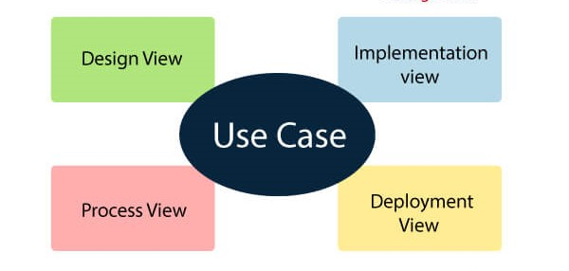

  - Use Case View
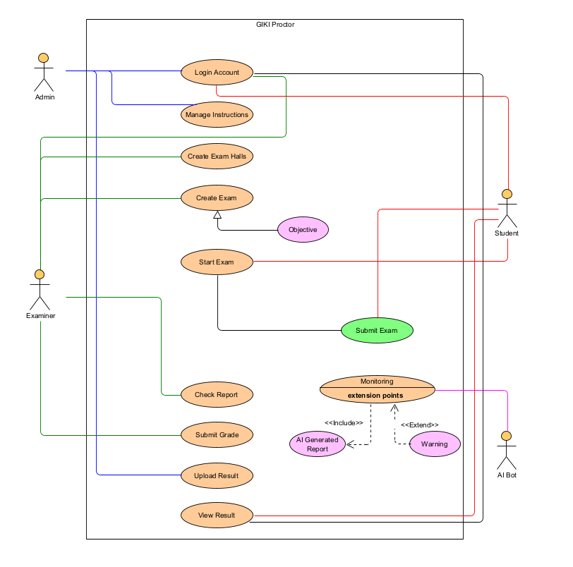

  - Class Diagram

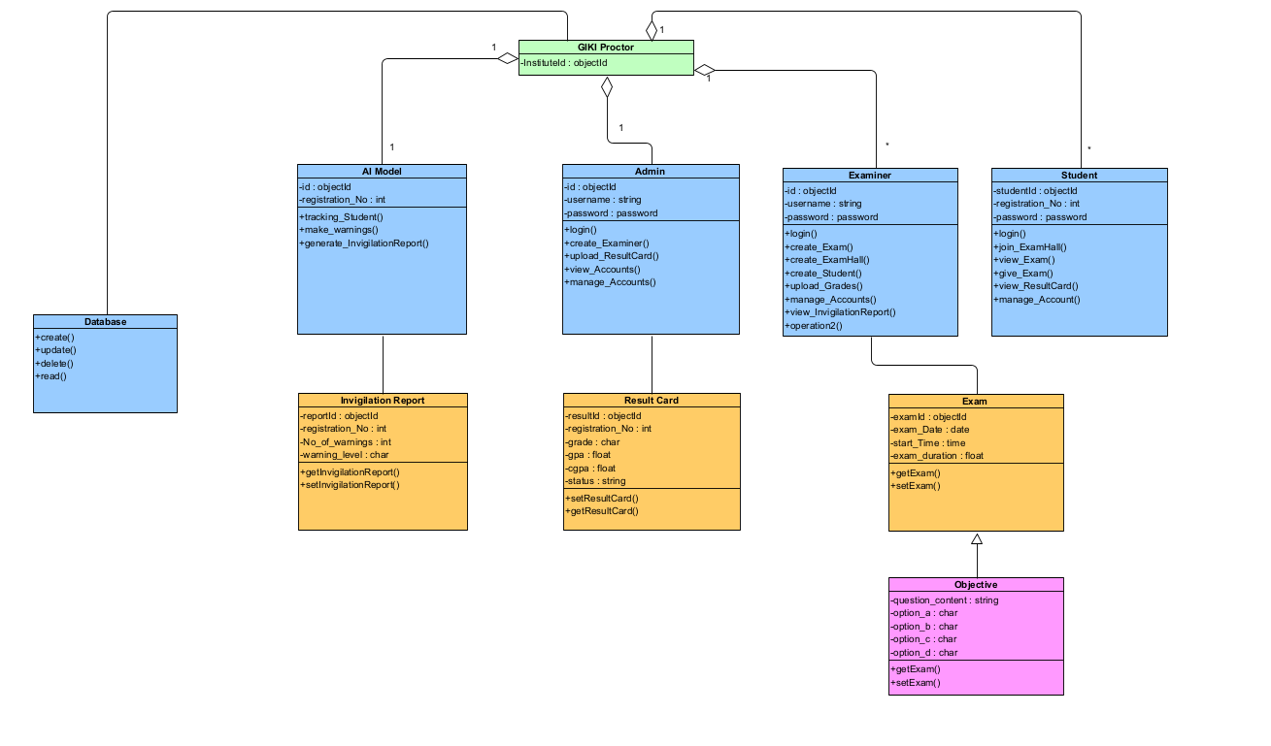

  - Student Sequence Diagram

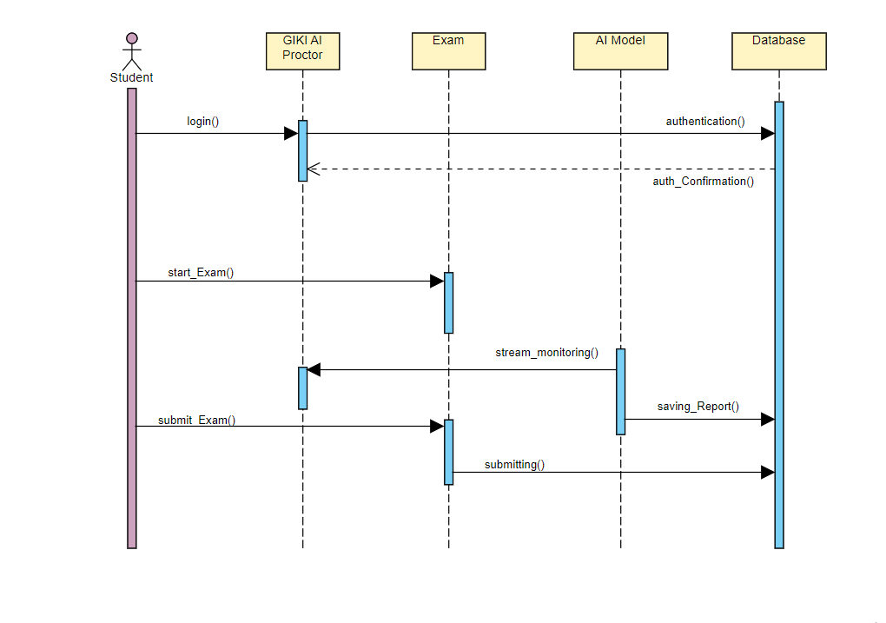

- Examiner Sequence Diagram:
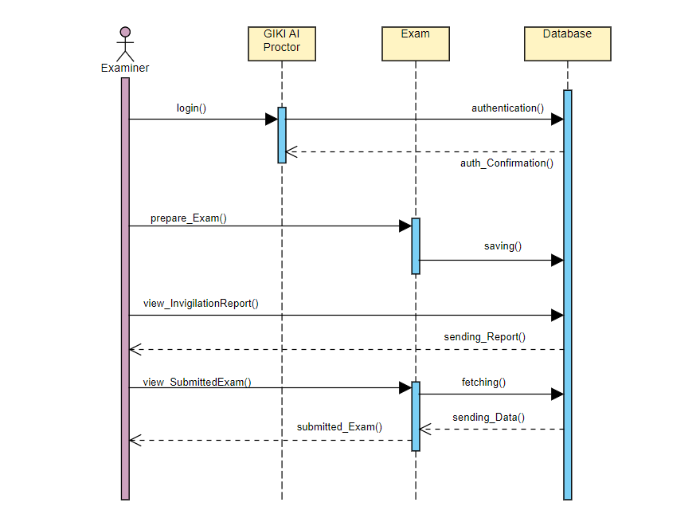

- Component Diagram
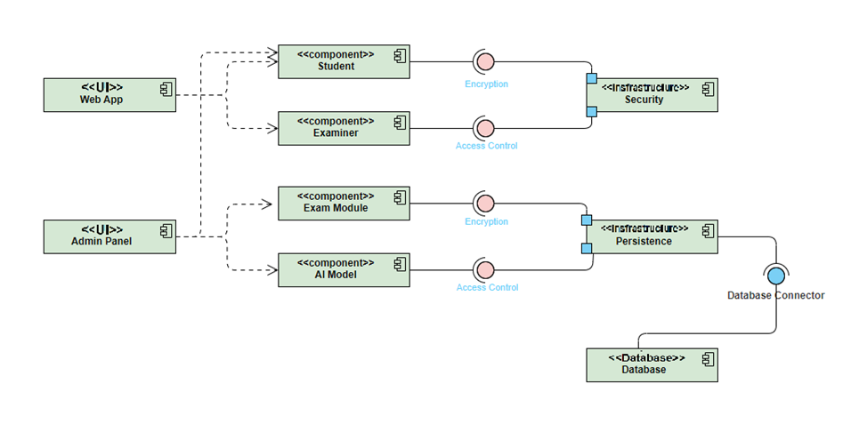
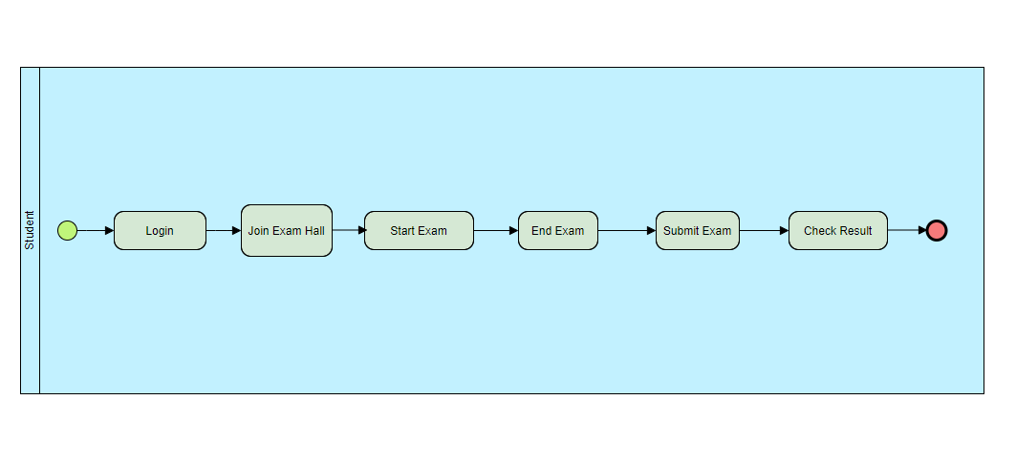
- Student Process View

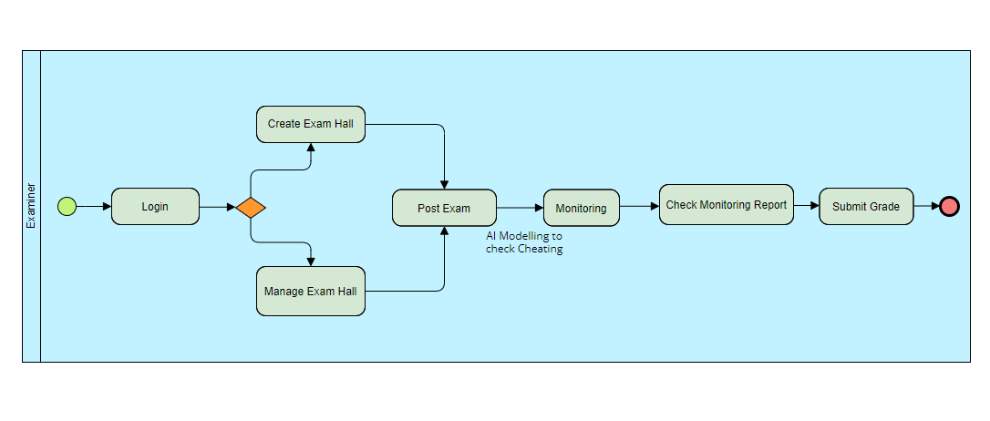

- Examiner Process View

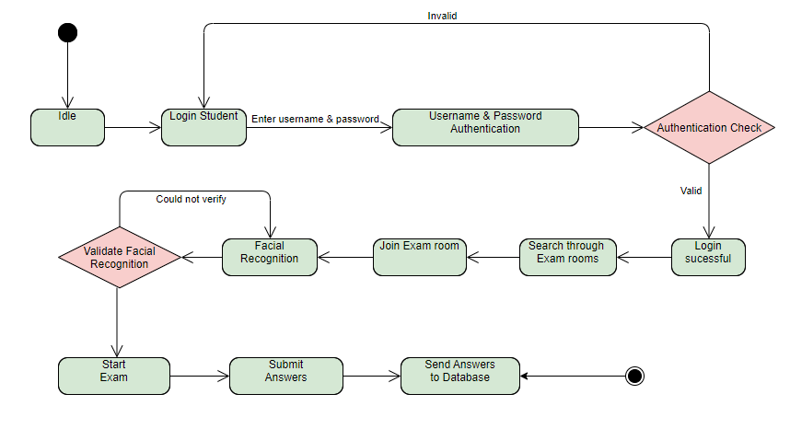
- State Chart Diagram

- Deployment Diagram

